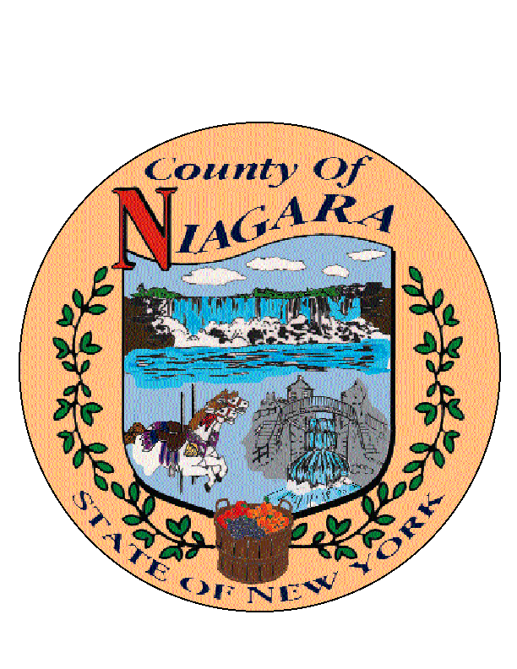

***JOSEPH A. JASTRZEMSKI***

**County Clerk**

***MATTHEW L. PARISH***

**First Deputy County Clerk**

**(716) 439-7022**

**(716) 439-7035 Fax**

**NIAGARA** **COUNTY**

**COUNTY CLERK'S OFFICE**

**COURTHOUSE**

**P.O. BOX 461**

**LOCKPORT, NY 14095-0461**

NN

**2025 HOLIDAY SCHEDULE**

|  |  |  |  |  |
| --- | --- | --- | --- | --- |
| **NEW YEAR’S DAY** | | **JANUARY 1, 2025** |  | **WEDNESDAY** |
| **MARTIN LUTHER KING JR. DAY** | | **JANUARY 20, 2025** |  | **MONDAY** |
| **PRESIDENTS’ DAY** |  | **FEBRUARY 17, 2025** |  | **MONDAY** |
| **GOOD FRIDAY** |  | **APRIL 18, 2025** |  | **FRIDAY** |
| **MEMORIAL DAY** |  | **MAY 26, 2025** |  | **MONDAY** |
| **INDEPENDENCE DAY** |  | **JULY 4, 2025** |  | **FRIDAY** |
| **LABOR DAY** |  | **SEPTEMBER 1, 2025** |  | **MONDAY** |
| **COLUMBUS DAY** |  | **OCTOBER 13, 2025** |  | **MONDAY** |
| **VETERANS DAY** |  | **NOVEMBER 11, 2025** |  | **TUESDAY** |
| **THANKSGIVING DAY** |  | **NOVEMBER 27, 2025** |  | **THURSDAY** |
| **DAY AFTER THANKSGIVING** |  | **NOVEMBER 28, 2025** |  | **FRIDAY** |
| **CHRISTMAS DAY** |  | **DECEMBER 25, 2025** |  | **THURSDAY** |